RStudio is an integrated development environment (IDE) for R. It includes a console, syntax-highlighting editor that supports direct code execution, as well as tools for plotting, history, debugging and workspace management.

1. **You must do this first:** Download and install R by going to <https://cloud.r-project.org/>.
   * 1. If you are a Windows user: Click on “Download R for Windows”, then click on “base”, then click on the Download link.
     2. If you are macOS user: Click on “Download R for (Mac) OS X”, then under “Latest release:” click on R-X.X.X.pkg, where R-X.X.X is the version number. For example, the latest version of R as of November 25, 2019 was R-3.6.1.
     3. If you are a Linux user: Click on “Download R for Linux” and choose your distribution for more information on installing R for your setup.
2. **You must do this second:** Download and install RStudio at <https://www.rstudio.com/products/rstudio/download/>.
   * 1. Scroll down to “Installers for Supported Platforms” near the bottom of the page.
     2. Click on the download link corresponding to your computer’s operating system.

**Using R via RStudio**

After you install R and RStudio on your computer, you’ll have two new *programs* (also called *applications*) you can open. We’ll always work in RStudio and not in the R application.

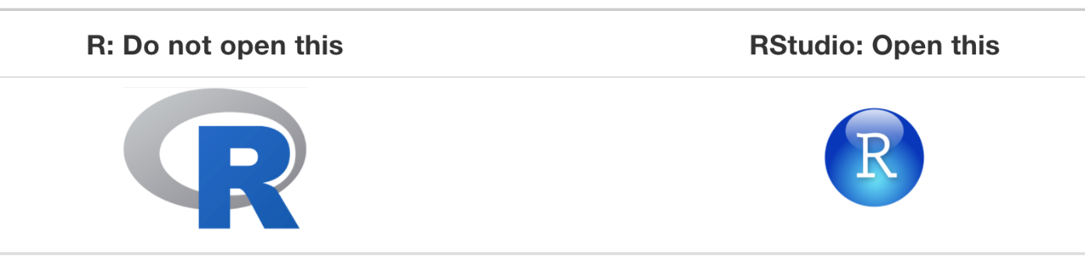

### What do we see when we open R?

### The four quadrants of an RStudio screen

### We write in the Script window

### Output comes in the Console window

### The Packages window holds our packages (more on this later)

### The Environment window holds what we have imported in our environment (more on this later).

### Let’s look at the Iris dataset

### In the script window, type the following on Line 1:

### # The datasets package needs to be loaded to access our data

### # For a full list of these datasets, type library(help = "datasets")

**library**(datasets)

data(iris)

summary(iris)

Sepal.Length Sepal.Width Petal.Length Petal.Width Species

Min. :4.300 Min. :2.000 Min. :1.000 Min. :0.100 setosa :50

1st Qu.:5.100 1st Qu.:2.800 1st Qu.:1.600 1st Qu.:0.300 versicolor:50

Median :5.800 Median :3.000 Median :4.350 Median :1.300 virginica :50

Mean :5.843 Mean :3.057 Mean :3.758 Mean :1.199

3rd Qu.:6.400 3rd Qu.:3.300 3rd Qu.:5.100 3rd Qu.:1.800

Max. :7.900 Max. :4.400 Max. :6.900 Max. :2.500

### What are Packages?

**Packages** are the fundamental units of reproducible R code. They include reusable R functions, the documentation that describes how to use them, and sample data. In this section you’ll learn how to turn your code into packages that others can easily download and use. Writing a package can seem overwhelming at first. So start with the basics and improve it over time. It doesn’t matter if your first version isn’t perfect as long as the next version is better.